Session 5 - 1
class Solution {
public int[][] matrixBlockSum(int[][] mat, int k) {
int m = mat.length;
int n = mat[0].length;

int[][] pref = new int[m + 1][n + 1];
for (int r = 1; r <= m; r++) {
for (int c = 1; c <= n; c++) {
pref[r][c] = mat[r - 1][c - 1]
+ pref[r - 1][c]
+ pref[r][c - 1]
- pref[r - 1][c - 1];
}
}

int[][] ans = new int[m][n];
for (int i = 0; i < m; i++) {
for (int j = 0; j < n; j++) {
int r1 = Math.max(0, i - k);
int c1 = Math.max(0, j - k);
int r2 = Math.min(m - 1, i + k);
int c2 = Math.min(n - 1, j + k);

ans[i][j] = pref[r2 + 1][c2 + 1]
- pref[r1][c2 + 1]
- pref[r2 + 1][c1]
+ pref[r1][c1];
}
}

return ans;
}
}
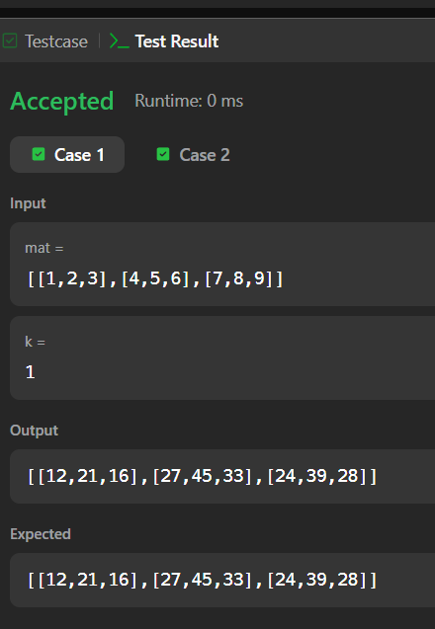

Session 5 - 2

import java.io.*;
import java.util.*;
import java.util.stream.*;
import static java.util.stream.Collectors.joining;
import static java.util.stream.Collectors.toList;

public class Solution {

// Complete the matrixRotation function below.
public static void matrixRotation(List<List<Integer>> matrix, int r) {
int m = matrix.size();
int n = matrix.get(0).size();

// Convert to a 2D primitive array for faster indexing and updates
int[][] mat = new int[m][n];
for (int i = 0; i < m; i++) {
for (int j = 0; j < n; j++) {
mat[i][j] = matrix.get(i).get(j);
}
}

// Calculate total layers
int numLayers = Math.min(m, n) / 2;

for (int layer = 0; layer < numLayers; layer++) {
List<Integer> list = new ArrayList<>();

// 1. Extract elements from the current layer in anti-clockwise order
// Top row
for (int j = layer; j < n - layer; j++) {
list.add(mat[layer][j]);
}
// Right column (minus top corner)
for (int i = layer + 1; i < m - layer; i++) {
list.add(mat[i][n - 1 - layer]);
}
// Bottom row (right to left, minus right corner)
for (int j = n - 2 - layer; j >= layer; j--) {
list.add(mat[m - 1 - layer][j]);
}
// Left column (bottom to top, minus bottom and top corners)
for (int i = m - 2 - layer; i > layer; i--) {
list.add(mat[i][layer]);
}

int size = list.size();
// Effective rotations needed for this layer
int effR = r % size;

// 2. Put elements back into the layer shifted by effR positions
int idx = effR;

// Top row
for (int j = layer; j < n - layer; j++) {
mat[layer][j] = list.get(idx);
idx = (idx + 1) % size;
}
// Right column
for (int i = layer + 1; i < m - layer; i++) {
mat[i][n - 1 - layer] = list.get(idx);
idx = (idx + 1) % size;
}
// Bottom row
for (int j = n - 2 - layer; j >= layer; j--) {
mat[m - 1 - layer][j] = list.get(idx);
idx = (idx + 1) % size;
}
// Left column
for (int i = m - 2 - layer; i > layer; i--) {
mat[i][layer] = list.get(idx);
idx = (idx + 1) % size;
}
}

// 3. Print the resulting matrix
StringBuilder sb = new StringBuilder();
for (int i = 0; i < m; i++) {
for (int j = 0; j < n; j++) {
sb.append(mat[i][j]);
if (j < n - 1) {
sb.append(" ");
}
}
sb.append("\n");
}
System.out.print(sb.toString());
}

public static void main(String[] args) throws IOException {
BufferedReader bufferedReader = new BufferedReader(new InputStreamReader(System.in));

String[] firstMultipleInput = bufferedReader.readLine().replaceAll("\\s+$", "").split(" ");

int m = Integer.parseInt(firstMultipleInput[0]);
int n = Integer.parseInt(firstMultipleInput[1]);
int r = Integer.parseInt(firstMultipleInput[2]);

List<List<Integer>> matrix = new ArrayList<>();

for (int i = 0; i < m; i++) {
String[] matrixRowTempItems = bufferedReader.readLine().replaceAll("\\s+$", "").split(" ");

List<Integer> matrixRowItems = new ArrayList<>();
for (int j = 0; j < n; j++) {
matrixRowItems.add(Integer.parseInt(matrixRowTempItems[j]));
}

matrix.add(matrixRowItems);
}

matrixRotation(matrix, r);

bufferedReader.close();
}
}
